Sweet potato gnocchi
with sage butter and parmesan

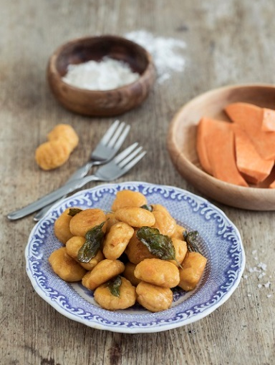
Ingredients for 4 servings:
500 g sweet potatoes from North Carolina
170 g ricotta cheese
100 g grated parmesan
240–300 g wheat flour
1 tsp. salt
100 g butter
1 bunch of fresh sage

Directions:

- Peel sweet potatoes, cut them into large cubes and boil them in lightly salted water. Drain the water and place the sweet potatoes in a bowl, allow to cool and then mash into a puree using a potato masher or hand blender.

- Add ricotta, parmesan and salt and stir well. Gradually fold in the wheat flour and knead the ingredients into a sticky dough.

- Dust a work surface with flour and cut the dough into six pieces. Form a long roll out of each. Cut the roll into medium-sized gnocchi and press the typical gnocchi pattern onto each piece with the back of a fork.

- Bring salted water to a boil in a saucepan. Add the gnocchi and cook until they float to the surface. Fish the gnocchi out of the pot with a ladle and place on a plate.

- Simmer the butter in a pan while stirring until it turns brown and gives off a nutty aroma. Add the gnocchi and roast until golden brown.

- Pluck, wash and add the sage leaves. Stir at low heat until all gnocchi are mixed with the sage and the butter.

